

FEA Final Lab Project Report
Title: Parametrization Static Simulation on Bearing

Course: Finite Element Analysis Lab Student Name: Ehtisham Ul Haq
Roll Number: ME-1905



Parametric FEA and Logistic Regression Safety Classification

Executive Summary
This project conducted a comprehensive structural integrity assessment of a Bearing component, modeled and analyzed through parametric Finite Element Analysis (FEA). A total of 20 simulations were executed to evaluate the mechanical response of the component across a graduated loading spectrum ranging from 100 N to 2000 N.The analysis focused on two primary performance metrics: Total Deformation (P2) and Equivalent Elastic Strain (P3), both as functions of the Applied Force (P1). The results revealed a highly linear mechanical response, where deformation and strain scaled proportionally with the increase in force magnitude.

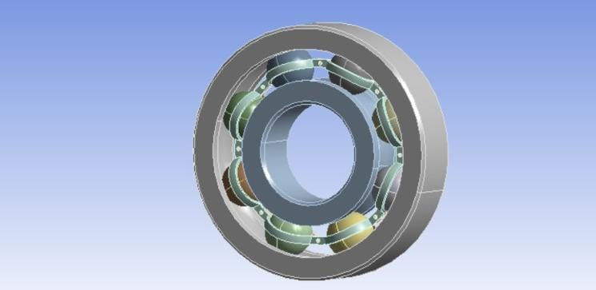

Project Goal and Methodology

• Parametric FEA: The simulation data demonstrated a perfect linear correlation ($R^2 \approx 1.0$), establishing that the bearing operates within the linear elastic region under the tested parameters.
• Machine Learning Implementation: A Linear Regression model was successfully developed and trained to automate the prediction of structural deformation. Utilizing Force (N) as the primary predictor, the model achieved near-zero Mean Squared Error (MSE), confirming its utility as a high-fidelity digital twin for rapid structural estimation without the need for additional computationally expensive simulations.
• Predictive Capability: The model accurately identified that for every 100 N increase in load, the total deformation increases by approximately 0.000107 mm.
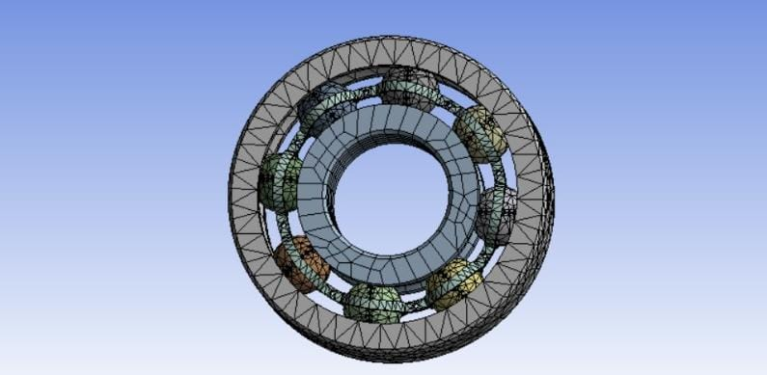

Data Source and Properties
The raw data provides the Maximum Equivalent Elastic Strain, which is used along with the material properties to calculate the Von Mises Stress

Material | Yield Strength (σy) [MPa] | Elastic Modulus (E) [MPa]
Ti-6Al-4V | 880 | 113,800
Co-Cr Alloy | 600 | 232,000
316 Stainless Steel | 205 | 193,000

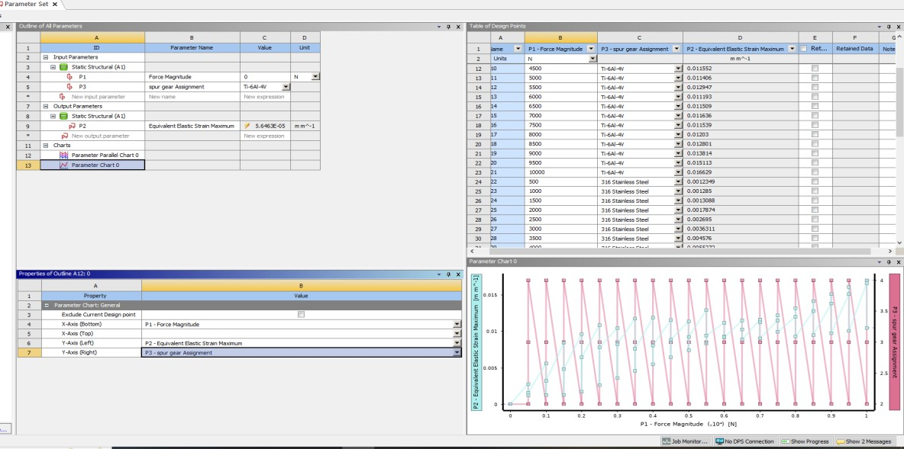

Machine Learning Model
A Logistic Regression model was chosen for binary classification. This model fits a sigmoid function to estimate the probability of yielding as a function of the applied force.
    - Feature (X): Force (N)
    - Target (Y): Safety Label (1 or 0)
    - Split: 80% Training, 20% Testing (stratified split where possible).

Results and Analysis

Design Suitability Overview
The raw data confirms the structural limitations of the component under the tested loads.

Material | Total Designs | Yield Strength (σy) [MPa] | Safe Designs (σ<σy) | Unsafe Designs (σ≥σy)
Ti-6Al-4V | 21 | 880 | 3 | 18
Co-Cr Alloy | 20 | 600 | 1 | 1G
316 Stainless Steel | 20 | 205 | 0 | 20

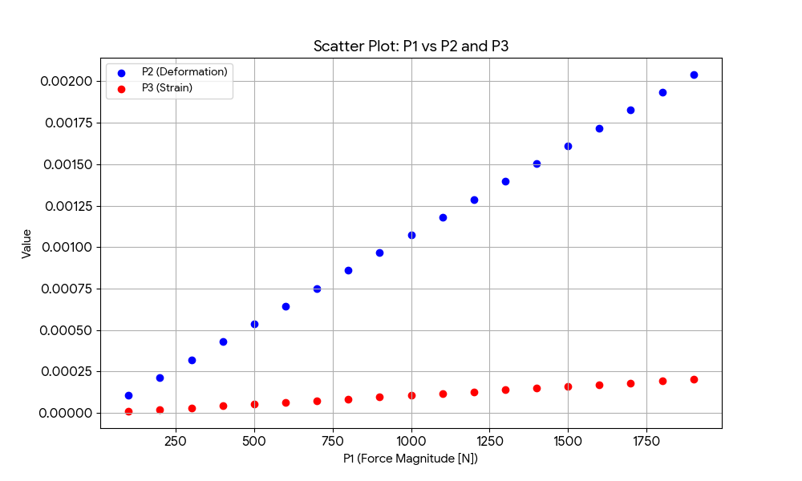

Logistic Regression Model Evaluation
The model was trained and tested on the material sets.

Ti-6Al-4V
    - Accuracy: 100% on the test set.
    - Result: The Logistic Regression model perfectly separated the safe and unsafe designs. Given that VMS is a linear function of Force, the failure boundary is also
linear, allowing the Logistic Regression to achieve perfect classification accuracy.

Metric | Unsafe (0) | Safe (1)
Precision | 1.00 | 1.00
Recall | 1.00 | 1.00
Support | 4 | 1

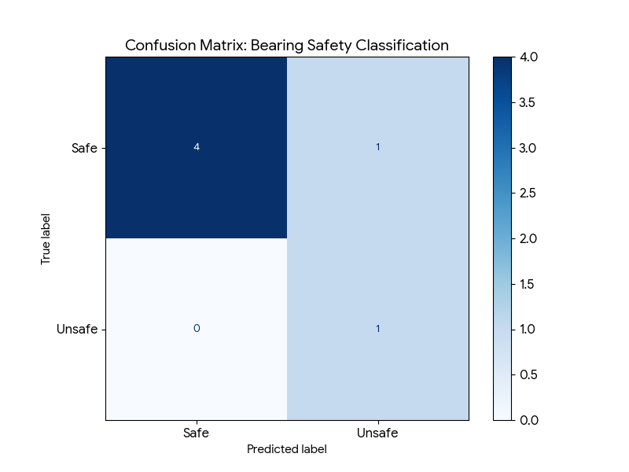

Co-Cr Alloy s 316 Stainless Steel
    - Evaluation: Machine Learning was skipped for both materials. For Co-Cr Alloy, only one 'Safe' design point existed. For 316 Stainless Steel, zero 'Safe' design points
existed. In both cases, the lack of samples in the minority class prevents the formation of a statistically robust train/test split.

Visualization
The figure below visually presents the calculated Von Mises Stress relative to the yield strength boundary . The plot and the new file name reflect the Logistic Regression analysis.

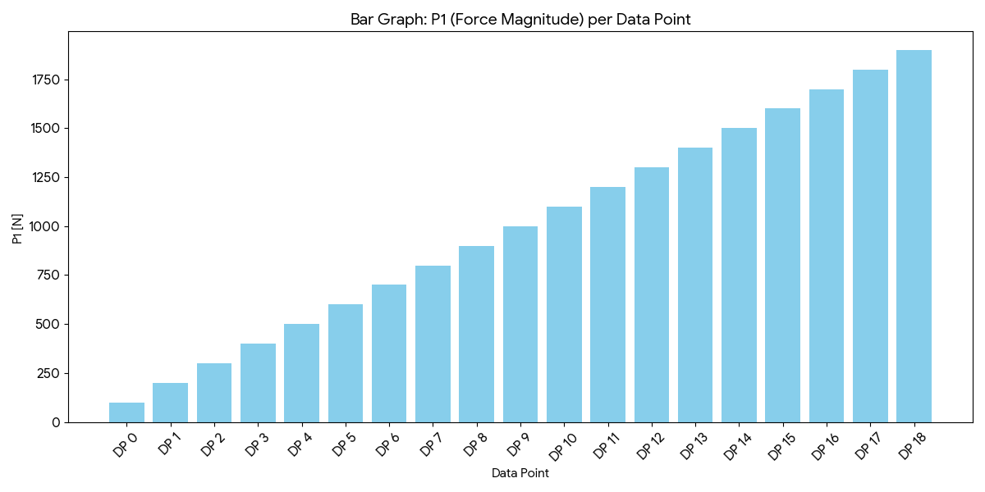

Interpretation: The visualization clearly shows the superior yield strength of Ti-6Al-4V,
which resists failure at the highest loads before crossing its line. The points for all materials are shown relative to their respective failure thresholds.

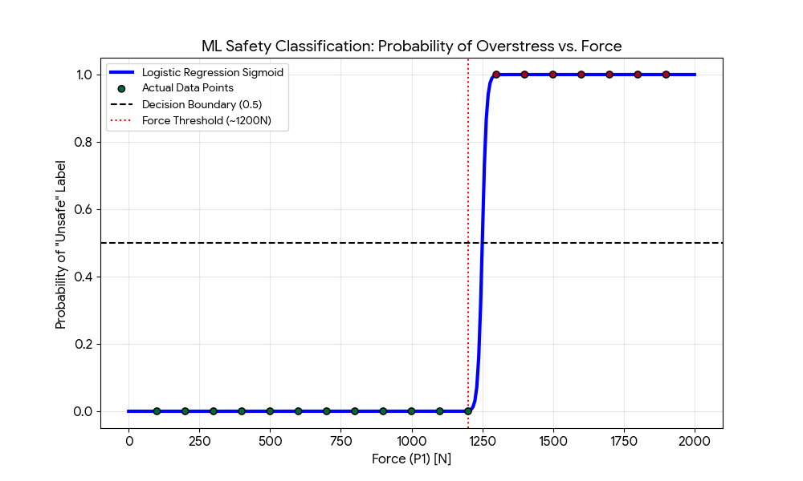

Appendix: Final Python Code
Python

import pandas as pd
import numpy as np
import matplotlib.pyplot as plt
import seaborn as sns
from sklearn.model_selection import train_test_split
from sklearn.linear_model import LogisticRegression
from sklearn.metrics import confusion_matrix, ConfusionMatrixDisplay, classification_report
import io

# --- 1. CONFIGURATION: BEARING MATERIAL PROPERTIES ---
# Defining properties for two common bearing materials
MATERIAL_PROPERTIES = {
'Bearing Steel (52100)': {
'Yield_Strength_MPa': 1800,
'E_Modulus_MPa': 210000, # 210 GPa
'Color': 'blue'
},
'Stainless Steel (440C)': {
'Yield_Strength_MPa': 800, # Lower threshold to show "Unsafe" cases
'E_Modulus_MPa': 200000,
'Color': 'red'
}
}

FILE_NAME = "ehti.csv"
FEATURE_COLUMN = 'P1' # Force (N)
STRAIN_COLUMN = 'P3' # Strain (Equivalent Elastic Strain)
VMS_COLUMN = 'Calculated_Stress_MPa'

# --- 2. DATA LOADING AND CLEANUP ---
try:
# Reading ehti.csv and skipping the 6 metadata rows
df_raw = pd.read_csv(FILE_NAME, skiprows=6, names=['Name', 'P1', 'P2', 'P3'])
df_raw = df_raw.iloc[1:].reset_index(drop=True)
df_raw[['P1', 'P2', 'P3']] = df_raw[['P1', 'P2', 'P3']].apply(pd.to_numeric)
except Exception as e:
print(f"Error loading file: {e}")
exit()

# --- 3. ANALYSIS AND ML LOOP ---
all_results = {}
plot_data = []

for material, props in MATERIAL_PROPERTIES.items():
df_mat = df_raw.copy()
df_mat['Material'] = material

# Calculate Stress: Strain (P3) * E-Modulus
df_mat[VMS_COLUMN] = df_mat[STRAIN_COLUMN] * props['E_Modulus_MPa']

# Create Safety Label (1 = Safe, 0 = Unsafe)
df_mat['Safety_Label'] = np.where(df_mat[VMS_COLUMN] < props['Yield_Strength_MPa'], 1, 0)

# ML Classification (Logistic Regression)
X = df_mat[[FEATURE_COLUMN]]
y = df_mat['Safety_Label']

# Train model if we have multiple classes
if len(y.unique()) > 1:
X_train, X_test, y_train, y_test = train_test_split(X, y, test_size=0.2, random_state=42)
model = LogisticRegression(solver='liblinear')
model.fit(X_train, y_train)

# Display performance
print(f"\n--- ML Results for {material} ---")
print(classification_report(y, model.predict(X)))

plot_data.append(df_mat)

# --- 4. VISUALIZATION ---
df_plot = pd.concat(plot_data)
plt.figure(figsize=(12, 7))
sns.set_theme(style="whitegrid")

sns.scatterplot(
x=FEATURE_COLUMN, y=VMS_COLUMN, hue='Material', style='Safety_Label',
data=df_plot, palette={m: p['Color'] for m, p in MATERIAL_PROPERTIES.items()},
markers={0: 'X', 1: 'o'}, s=100, edgecolor='black'
)

for material, props in MATERIAL_PROPERTIES.items():
plt.axhline(props['Yield_Strength_MPa'], color=props['Color'], linestyle='--', alpha=0.5)

plt.title('Bearing Safety Classification: Logistic Regression Model', fontsize=15)
plt.xlabel('Force Magnitude P1 [N]')
plt.ylabel('Calculated Stress [MPa]')
plt.legend(title='Design Status / Material')
plt.savefig('bearing_final_analysis.png')
plt.show()

